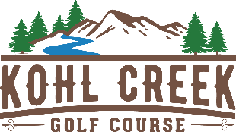
Kids Golf Clinic 2023
July 11, 12, 13, 17 9 am – 11:30 am
$149
Childs Name: ______________________________Age: ___________ Golf Experience? Y / N
Bringing golf clubs? Y / N
Parents Name: __________________________________
Parents Email: ___________________________ Phone: ____________
Please make a check payable to Kohl Creek Golf Course for $149.00, per child and mail or drop off to address below.
Snacks and drinks will be available to purchase, please bring cash as we have a minimum $5 credit card purchase.
RELEASE OF LIABILITY
My child is willingly participating in a Children’s Golf Clinic at Kohl Creek Course located at 3030 SW Advance Road, Wilsonville, OR 97070, a subsidiary of Sandelie Golf Club, Inc. I recognize golf requires physical exertion and am fully aware of the risk involved.
I represent and warrant that my child has no medical condition that would prevent his/her participation in physical activity.
I agree to assume responsibility for risks, injury or damage known or unknown that might occur as a result of participating in the Kohl Creek Golf Clinic. I voluntarily release Kohl Creek/Sandelie Golf Club, Inc. for injuries my child may sustain as a result of participation.
I have read the above release and waiver of liability and fully understand its contents. I voluntarily agree to its contents above.

Signature of Parent: ______________________________________ Date: _____________

Kohl Creek Golf Course ▪ 3030 SW Advance Road ▪ Wilsonville, OR 97070 ▪ (503) 682-2022
Follow us on facebook at Kohl Creek

